**Matching of fiducial lines to slice intersection points in ultrasound images**

Alexis Boucharin, Andras Lasso, Csaba Pinter, Tamas Heffter, Gabor Fichtinger

*Laboratory for Percutaneous Surgery, School of Computing, Queen’s University, Kingston, Ontario, Canada*

***Abstract***

Effective ultrasound-guided radiation therapy of prostate cancer requires accurate calibration of the ultrasound systems, this is why many calibration phantoms exist to allow these calibration tasks to be performed, however none of them is perfect. Therefore, one must provide new software for each phantom used by the calibration algorithm process as each is designed to perform different calibration tests. Moreover different approaches have to be tested and several test iterations are required to design a good phantom. We propose an automatic method that performs calibration and quality assurance tests on several phantom configurations with no manual tuning required. The idea is to introduce a phantom description scheme to specify the features of the phantom and create a generic algorithm that can work without any manual tuning and optimize on any phantom by only requiring its description via a phantom definition file. The method automatically computes segmentation and registration parameters which provide more accuracy and avoid a lengthy trial and error process to determine these parameters. From the fiducial point segmentation algorithm results developed by Chen et al. in 2009, lines consisting of the fiducial candidate points are computed and automatically registered by our method to match the phantom description. A 3D Slicer module was developed, which shows the matching between fiducial points and centroids of the point segmentation results. This module was extensively used for software debugging, testing, and creation of ground truth data sets for automatic testing. Our tests on real ultrasound data sets have given promising results and the method managed to match two lines to their actual position as well as computing automatically and successfully the maximum and minimum inclination of these lines for registration purpose.

*Index terms: ultrasound imaging, quality assurance, calibration, segmentation, prostate brachytherapy.*

***Purpose***

Ultrasound-guided low dose rate brachytherapy is now one of the popular therapy choices for treatment of early prostate cancer (Nag, 2000). During the treatment procedure radioactive seeds are inserted into the tumor. To deliver high radiation dose to the tumor and minimize irradiation of healthy tissues the ultrasound system has to provide accurate and reliable information about the prostate and seed positions. This requires accurate calibration and image quality assurance procedures. In current clinical practice these procedures are manual and therefore lengthy, require an operator with special skills and experience, and the results may be operator-dependent. All these limitations could be resolved by automating these procedures. Yet, this automation is a challenging task, requiring extensive research and development work.

One of the most important components of an ultrasound calibration and image quality assurance system is the measurement phantom. The phantom is an object that can be imaged by the ultrasound device and contains a number of precisely manufactured features, which provide ground truth data for various measurements. Unfortunately, currently there is no one single phantom that is suitable for performing all the required tests. More research and development work is required to develop and optimize new phantoms. Automatic fiducial line segmentation is therefore an important part of image quality assurance and calibration of ultrasound imaging systems as fiducial line detection is needed to estimate accurately the calibration parameters. And some algorithms already exist that could be utilized for automated quality assurance. However, typically new software algorithm version has to be developed and tuned for each phantom version. The tolerance parameters are often obtained via a trial and error process, which is time-consuming and does not guarantee optimal results.

We propose a method that helps this research and development work by not requiring any software changes when using different phantom geometries, i.e. different fiducial line patterns in different phantom versions. This method detects coplanar lines that be contained in multiple planes for any number of lines per plane as well as any number of points per line. This method can also determine the tolerance parameters automatically from inputs such as maximum angular movement. These parameters are essential to perform an accurate and fast segmentation.

***Method***

1. *Overview*

Each phantom includes a specific number of fiducial lines, these lines are physical lines of known positions and their detection provides a ground truth position for the calibration and image quality assurance. The method computes, from a list of segmented fiducial points provided by the fiducial segmentation algorithm by (Chen, 2009), a list of fiducial points in the image plane registered to the actual fiducial lines they belong to in the phantom. The method also pre-computes automatically different segmentation parameters with precision and low input requirements.

1. *Phantom definition*

The number of fiducial lines (fiducial points in a cross plane) is provided in the phantom definition file, as well as their basic structures such as parallel fiducial lines and Z-shaped fiducial structure. The number of these structures is not limited and is provided in the phantom definition file. The XML format was chosen for its simplicity to be interpreted by both humans and computers and because it is a standard format. Here is an example of a phantom definition file:

<PhantomDefinition version="1.0">

<Description Institution="Queen's University PerkLab" Version="1.0" Type="Double-N" Name="fCAL" /> <Geometry>

<NWire>

<Wire Name="E3_e3" EndPointBack="20.0 40.0 5.0" EndPointFront="20.0 0.0 5.0" Id="1"/>

<Wire Name="F3_j3" EndPointBack="45.0 40.0 5.0" EndPointFront="25.0 0.0 5.0" Id="2"/>

<Wire Name="K3_k3" EndPointBack="50.0 40.0 5.0" EndPointFront="50.0 0.0 5.0" Id="3"/>

</NWire>

<NWire>

<Wire Name="E4_e4" EndPointBack="20.0 40.0 0.0" EndPointFront="20.0 0.0 0.0" Id="4"/>

<Wire Name="J4_f4" EndPointBack="25.0 40.0 0.0" EndPointFront="45.0 0.0 0.0" Id="5"/>

<Wire Name="K4_k4" EndPointBack="50.0 40.0 0.0" EndPointFront="50.0 0.0 0.0" Id="6"/>

</NWire>

</Geometry>

<Parameters>

ScalingEstimation="0.19"

ImageScalingTolerancePercent="-10 10 -10 10"

ImageNormalVectorInPhantomFrameEstimation="0 0 1"

ImageNormalVectorInPhantomFrameMaximumRotationAngleDeg="-10 10 -10 10 -5 5"

<\Parameters>

</PhantomDefinition>

Figure 1: Example of Phantom Definition File.

1. *Generic method for fiducial pattern recognition and automatic computation of tolerance parameters*

From the list of fiducial points, *n*-point lines are computed and sorted by their intensity so that we have a list of lines each made of *n* fiducial points. Then, a backtracking algorithm is performed on the *n*-point lines found previously to match the actual lines made from the fiducial points from the phantom definition file. The choice for a backtracking algorithm is its simplicity and the fact that there are not too many candidate lines so the computation time of this part of the method is not preponderant. Once the lines are correctly detected, we can determine from image orientation and a transform matrix the correspondence between the fiducial points we found the actual one and therefore register them to the labels provided in the phantom definition file.

The different thresholds to accept points on a line or to register a potential line to an actual one is computed by the algorithm instead of implemented by a trial and error process. From the angular maximum movements of the ultrasound probe, we can determine how far from the actual position the candidate line can be. This angular maximum movement provides the range in which the image can actually be, as the image plane might not necessarily be perpendicular to the fiducial lines due to user movements, or could be slightly rotated around one axis or the other. These angular parameters can be obtained from the phantom definition file and the input data and would allow an optimal choice of threshold parameters that are automatically determined for any line configuration in the phantom. From these angles we can estimate the range of potential image plane positions and orientations by applying three rotations, one around each phantom coordinate system axis. Then we can compute the intersection of the fiducial plane, defined by three wires in a Z-shape configuration or by parallel lines, and the image plane, and then compute the maximum and minimum possible inclination of the intersection line in the image plane. This computation will provide us automatically two important segmentation parameters with high accuracy.

1. *Implementation*

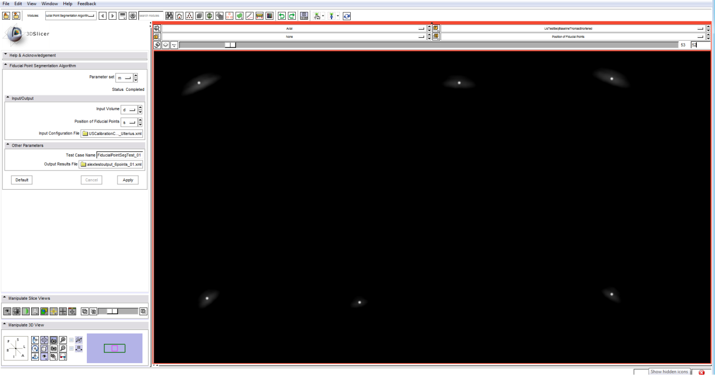The method has been developed in C++, using the **Insight Segmentation and Registration Toolkit** (ITK) for portability, speed, and robustness. A 3D Slicer module has been developed for visualization of input data and results. This module was extensively used for software debugging, testing, and creation of ground truth data sets for automatic testing. A screenshot of the 3D Slicer module is shown in Figure 2.

Figure 2: Slicer Module displaying the dot segmentation result. The bright dots are the segmented centroids of the fiducial dots.

The algorithm is tested every night using CDash, which provides a consistent tool for testing and analyzing different information about the method such as the speed of computation.

***Results and Discussion***

The automatic computation of selected segmentation parameters and minimum and maximum angle of a line in the image plane, has been successfully tested on several ultrasound image sequences. The next steps will be to extend the list of parameters that can be computed automatically to make the method as operator independent as possible and to compute accurate segmentation parameters without a trial and error process. The method also detects 3-point lines within an image with success.

***Conclusion***

The method we presented provides good segmentation results on the multiple datasets while some segmentation tolerance parameters are computed automatically. It also matched successfully segmented fiducial points in the image plane to the fiducial lines they belong to.

***References***

Chen, T. T. (2009). Chen, T.K., Thurston, A.D., Ellis, R.E., and Abolmaesumi, P. *Ultrasound in Med. & Biol, 35(1) pp. 79–93*.

L., B. (2011). Automatic fiducial localization in ultrasound images for a thermal ablation validation platform. *SPIE Medical Imaging* (p. pp. 796421). Lake Buena Vista (Orlando), Florida, USA: SPIE.

Nag, S. (2000). Brachytherapy for prostate cancer: Summary of american brachytherapy society recommendations. *Seminars Urologic Oncol.*, pp. vol. 18, mo. 2, pp 133-136.

Pfeiffer, D. e. (2008, December 12). AAPM Task Group 128: Quality assurance tests for prostate brachytherapy ultrasounds systems. *Medical Physics*, pp. Vol. 35, pp. 5471-5489.